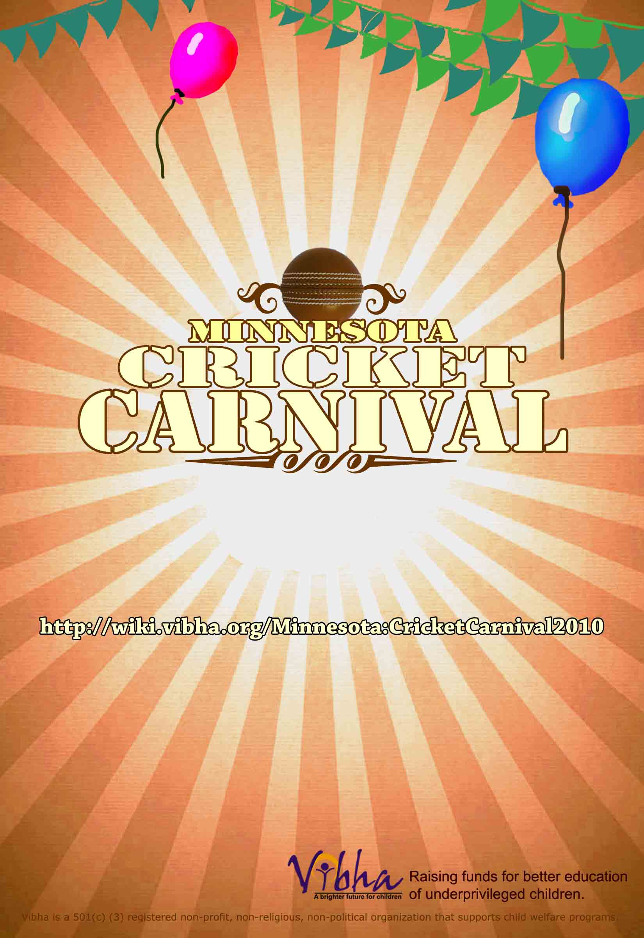

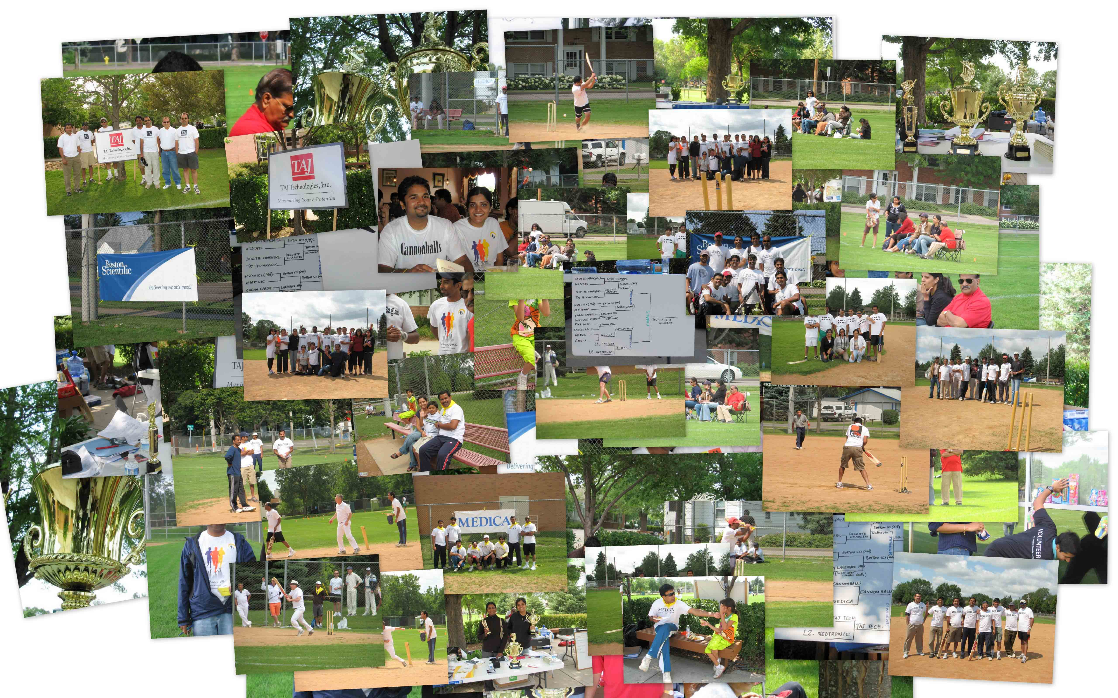

Dear Sir/Madam,

We present you with some exciting opportunities to advertise your business and engage the community this summer. The Minnesota chapter of Vibha is conducting a ‘Cricket Carnival’ during July 31st-Aug 1st, 2010. The event is filled with exciting cricket games and fun activities and is aimed at attracting all members of the Indian community across the twin cities. Given its success last year, we would like to have your support and encouragement to make this a successful event going forward.

Vibha is a non-profit organization founded in 1991 with a vision to ensure that every underprivileged child attains his or her right to education, health and opportunity. Since its inception, Vibha has supported more than 175 projects in India and 15 projects in USA. Vibha, with the support of patrons like you, has been able to positively impact the lives of more than 150,000 children.

The Minnesota (MN) action center of Vibha was founded in 1999. Since inception the action center has organized several awareness campaigns and fundraiser events such as Dream Mile, Annual Walk/Run, and fundraising concerts. The action center has had great success in reaching out to the local community. By partnering with us you have a unique opportunity to reach out and enlarge your business presence. Enclosed are more details about various sponsorship packages, and about Vibha’s efforts in India and the US.

Please feel free to contact us if you have any questions. We look forward to partnering with you and your organization to strengthen the cause of underprivileged children. If we can dream a little, then we can do a little. We hope to see you at Cricket Carnival 2010!

Sincerely,

Ramji Venkatasubramanian - 763-218-0798
Ram Vijayagopal - 651-294-9234
Chandra V Pakala - 651-216-1472

Website

http://wiki.vibha.org/Minnesota:CricketCarnival2010

About Vibha

Vibha (a Sanskrit word) literally means inner radiance or brightness and it signifies our organization’s vision of providing every underprivileged child with an opportunity for a brighter future.

We are a US based non-profit, non-religious, non-political volunteer organization that seeks to restore the promise of a future to underprivileged children by providing them access to education, healthcare, shelter and nourishment. Vibha volunteers in the US raise awareness and resources to support child development initiatives in India and the US. Since our inception in 1991, we have made a difference to the lives of underprivileged children and it has been possible only through the generosity and commitment of people like you.

Founded in 1991, today Vibha has a volunteer network of 800 volunteers spread across 15 Action Centers (Atlanta, Austin, Bay Area, Boston, Chicago, Dallas, Houston, Jacksonville, Los Angeles, Milwaukee, Twin Cities - Minnesota, New York, Philadelphia, Sacramento, Washington DC) and several other cities across the US and India.

Vibha – The Vision

To ensure that every underprivileged child attains his or her right to education, health and opportunity.

Vibha – The Mission

Educate, empower and enable every individual who wishes to make a positive difference in the life of an underprivileged child.

What we do

Since 1991, Vibha has raised nearly 6 million dollars with the help of patrons like you and supported more than 150,000 children through 165 grassroots projects. However, this is only a beginning. Today, over 39 million Indian children in the school-going age are currently outside the school system. About 1 million infants die every year. More than 15 million do not get immunized from preventable diseases. India is also home to 11 million child laborers. Vibha is currently working to help thousands of children in India. As of January 2009, Vibha supports the following projects in India and USA.

Project | Amount $ | Children
Alamb - Education & vocational training for slums girls, New Delhi | 24,522 | 400
Amta Block-Empowerment of older girls at Amta block, Howrah | 8,980 | 100
AURED-Aural Education for the Hearing Impaired | 13,928 | 470
BCT-Model Residential School | 32,250 | 135
BCT-Tribal Schools | 17,187 | 237
BTS' Sishu Tirtha & Green Buds -Child Care Centers | 13,181.5 | 150
CORP India-Vidya Sagar Vikas Kendra | 10,569 | 250
CTF-Let's Have Fun and Frolic (LAFF) | 10,678 | 3,000
DSS-NFE classes for Construction Worker's children | 45,000 | 250
GORD-Development of Schools in Somapalle, Mulakalacheruvu, Burkayalakota | 8,362 | 1,481
GORD-SIKSHANA | 9,574 | 1,906
GRSV-After school program for Dalit and Tribal children | 3,704 | 180
GSK-Uday Pathshala | 20,827 | 350
HEARDS-Integrated Program for Elimination of Child Labour | 9,762 | 99
HEP-Homeless Education Program | 500 | 2,400
Jan Madhyam-EORTTEC | 18,801 | 100
Jan Madhyam-Sahayog | 552.5 | 100
Jan Madhyam-Vistaar | 2,620.5 | 1,000
MyNewRedShoes – Bay Area Local Project (US) | 3,231 | 2,100
Navjyoti-Remedial Education Middle and Secondary Level | 11,274 | 320
Prayas-Education and Training Program for Deprived Mentally Challenged Children | 9,625 | 107
Rachana-Integrated Development Initiative for Rural Children | 21,406 | 1,250
RDO-Educational program for deprived and destitute rural children | 8,763 | 125
RMKM-Community based rehabilitation for Mentally Challenged Children | 20,473 | 330
RMKM-Swavlamban Ki Disha Mein | 10,367 | 50
SEA-Educating and empowering fishermen community children | 11,385 | 469
Sevalaya-School for Underprivileged children | 6,720 | 200
Shristi- Chiguru, an inclusive preschool for rural special needs children | 9,138 | 34
Sikshana | 15,022 | 2,148
Sikshana (Scaling Component) | 43,270 | 4,653
SKB-Child Welfare Project | 24,239 | 556
SVVPS- Dishari | 13,297.5 | 350
Swanirvar-Funding for teacher trainer | 3,638 | 15,000
Swanirvar-Teacher training for BTS | 219 | 100
Vidyarambam-Pre-primary education | 19,024 | 960
Total Amount disbursed in 2009 | 482,090 | 41,360

What we offer

Cricket Carnival Tournament

July 31st – Aug 1st, 2010

The publicity campaign for this event has kicked into high gear. Between now and the event day, the energetic volunteers of Vibha will be working to publicize the event in the Twin Cities. The publicity for the event will identify with children’s issues: education, health, and shelter – in short a better future for underprivileged children, and will include:

- Flyer publicity campaign
- Poster publicity campaign
- Email publicity campaign
- Web publicity
- Event Day Publicity: Banners, Booth, Announcements

You can participate

Features /Level | Title Sponsor | Platinum Sponsor | Gold Sponsor | Silver Sponsor
Amount | $1500 | $750 | $500 | $250
Event named with your business name | Yes | - | - | -
Free Team registration | 2 | 1 | 1 | 1
Free T-shirts with Team name | Yes | Yes | Yes | -
Banner Displayed in Batsman’s Backdrop | Yes (Top) | Yes (Bottom) | - | -
Banner Displayed in food area | - | - | Yes (Top) | Yes (Bottom)
Free Booth at event | Yes | Yes |  | -
Company name/logo on flyers, posters, e-mails/webpage. | Yes | Yes | Yes | -

Dream a little, Do a little
Proceeds from this event will benefit Vibha supported child development projects for underprivileged children in India.

ORGANIZATION NAME: __________________________________________________

CONTACT PERSON: __________________________________________________

ADDRESS: __________________________________________________

WEBSITE: __________________________________________________

EMAIL: __________________________________________________

PHONE: __________________________________________________

CHOOSE SPONSORSHIP OPTIONS:

TITLE SPONSOR $1500

PLATINUM SPONSOR $750

GOLD SPONSOR $500

SILVER SPONSOR $250

Check enclosed for amount: $ __________________

SIGNATURE: ______________________________ DATE: _________________

Make checks payable to: VIBHA.
Mail to: Ram Vijayagopal, 3421 Chandler road, Shoreview, MN-55126.

